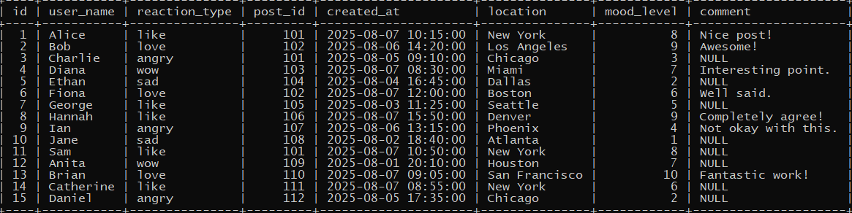

**LIKE**

**Write a query to find all reactions made by users whose names start with the letter ‘A’.**

select * from reaction where user_name like 'a%';



**AS (Alias)**

**Write a query to display user_name as Reactor and reaction_type as Type.**

select user_name as Reactor,reaction_type as Type from reaction;

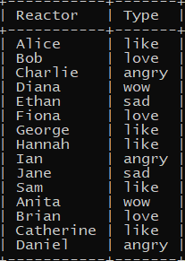

**BETWEEN**

**Write a query to find all reactions where the mood level is between 4 and 8.**

select * from reaction where mood_level between 4 and 8;

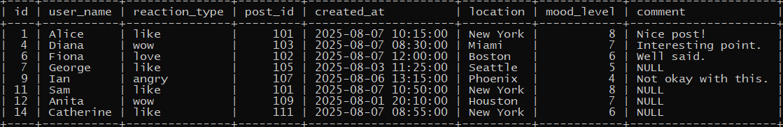

**AND**

**Write a query to get all reactions where the type is ‘like’ and the mood level is above 7.**

select * from reaction where reaction_type='like' and mood_level>7;



**OR**

**Write a query to list all reactions where the type is either ‘love’ or ‘angry’.**

select * from reaction where reaction_type in ('love', 'angry');

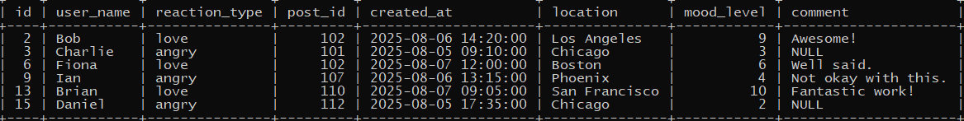

**NOT**

**Write a query to show all reactions that are not of type ‘sad’.**

select * from reaction where reaction_type not in ('sad');

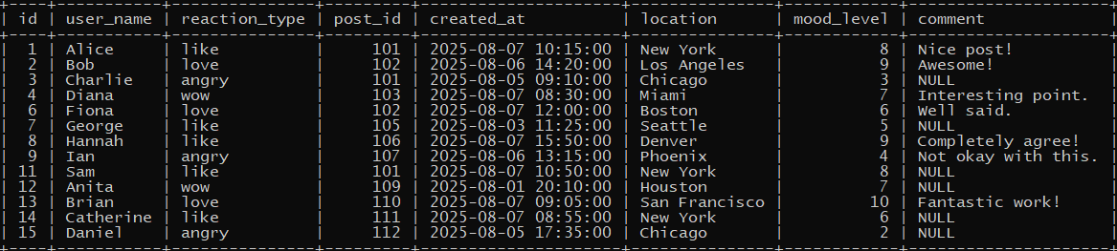

**IN**

**Write a query to find all reactions where the reaction type is ‘like’, ‘wow’, or ’love’.**

select * from reaction where reaction_type in ('like', 'wow', 'love');

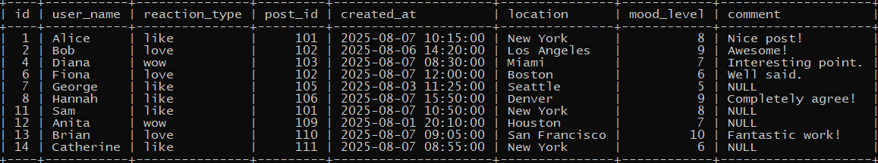

**IS NULL**

**Write a query to display all reactions where the comment is missing (i.e., NULL).**

select * from reaction where comment is null;

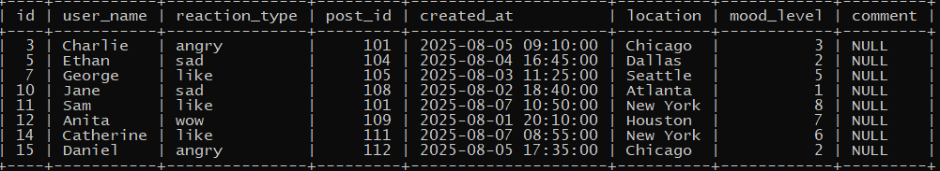

**IS NOT NULL**

**Write a query to find all reactions that include a comment.**

select * from reaction where comment is not null;

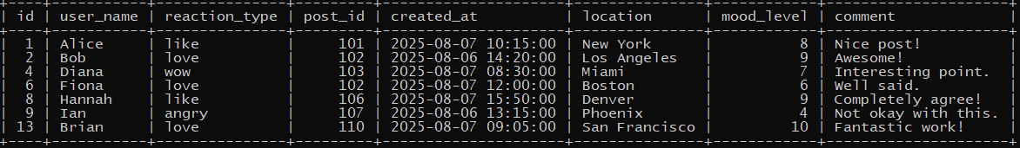

**UPPER()**

**Write a query to show all usernames in uppercase.**

select upper(user_name) from reaction;

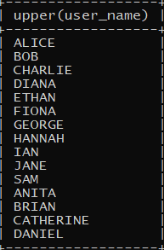

**LOWER()**

**Write a query to show all reaction types in lowercase.**

select lower(user_name) from reaction;

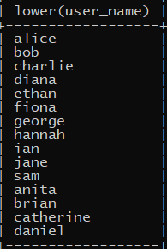

**LENGTH()**

**Write a query to find all users whose usernames are longer than 6 characters.**

select * from reaction where length(user_name)>6;



**NOW()**

**Write a query to find all reactions made today (based on the created_at column).**

select * from reaction where date(created_at)=current_date;

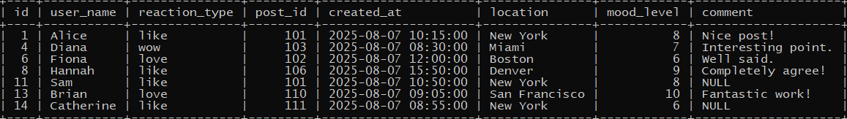

**DATE()**

**Write a query to extract and show only the date part from the created_at column.**

select date(created_at) from reaction;

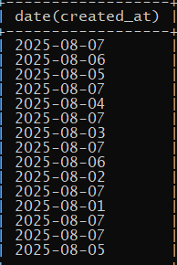

**LIKE with %**

**Write a query to find all users whose name contains the substring ‘an’.**

select * from reaction where user_name like '%an%';

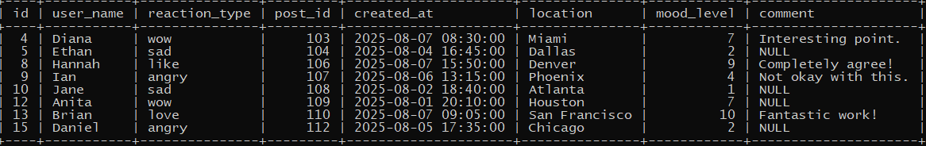

**ROUND()**

**Write a query to display each user’s mood level rounded to the nearest 5.**

SELECT user_name, ROUND(mood_level / 5.0) * 5 AS rounded_mood_level FROM Reaction;

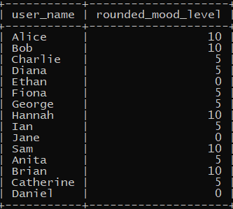

**SUBSTR + UPPER()**

**Write a query to show the first 2 letters of each user’s name in uppercase.**

SELECT UPPER(SUBSTRING(user_name, 1, 2)) AS first_two_letters FROM reaction;

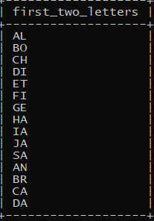

**NOT IN (with values)**

**Write a query to find all reactions not made on posts with IDs 10, 20, or 30.**

SELECT * FROM Reaction WHERE post_id NOT IN (10, 20, 30); 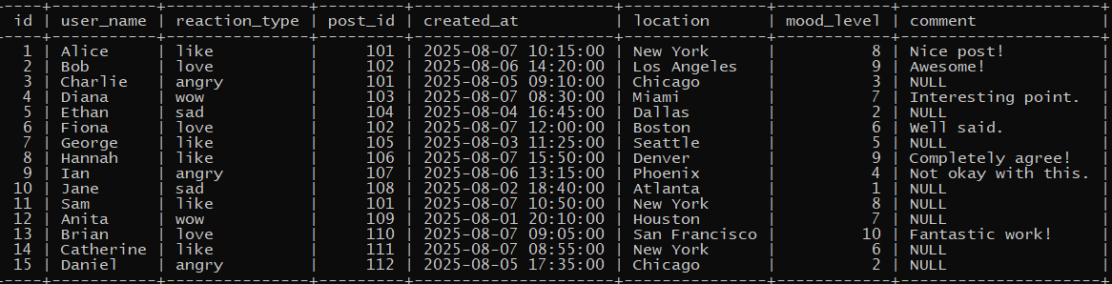

**COUNT and IS NULL**

**Write a query to count how many reactions have no comment.**

SELECT COUNT(*) AS no_comment_count FROM Reaction WHERE comment IS NULL;

